Use this link to access the report: [report.docx](https://monashuni-my.sharepoint.com/:w:/g/personal/rleo0008_student_monash_edu/Eeqck6K9-PdLn6HOCJi81p8BM2kY9aTkLpe34tQnzgl6gA?e=B2eLdI)

Use this link to access the BOM: [Team232 - Bill of Materials.xlsx](https://monashuni-my.sharepoint.com/:x:/g/personal/rleo0008_student_monash_edu/EYhk6vNM-shFnSLJAR0oozMBaKv_CO4ThuexstpMTgZ-Lw?e=rWJWaW)

(Sign in with your Monash email)

Click on “Open in Desktop App” to edit on your desktop Word app

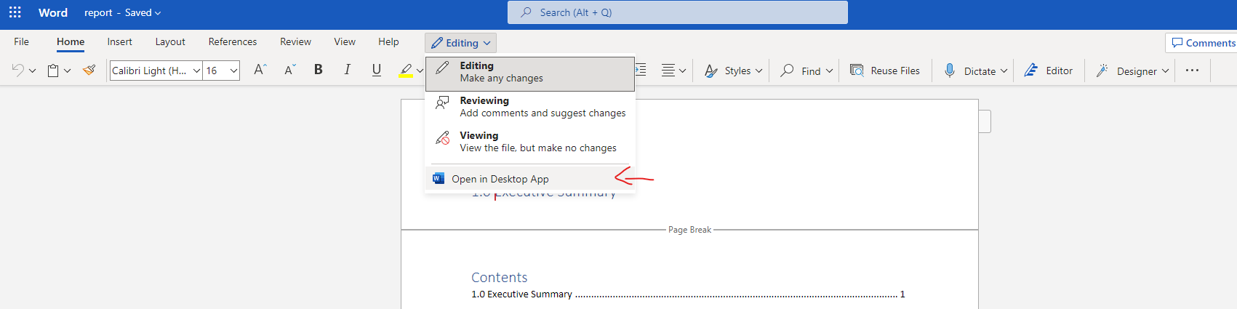

Click on “Open in Desktop App” to edit on your desktop Excel app

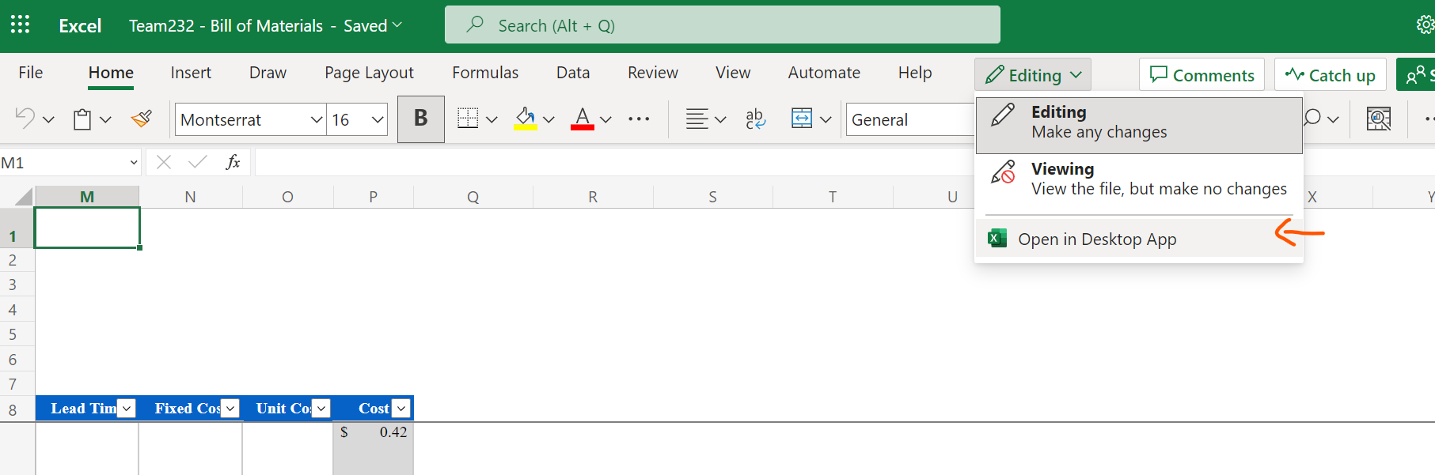

* Framing: the framing for this is that we are getting capital from someone, we will design, test, produce the product and sell branded as our own into the market.
* Pictorial illustrations of the team’s design
* This is meant to be a convincing funding proposal in some ways. Does it work, will it work...?
* The document must **not exceed 9 A4 pages** (excluding cover page) in length.
* All text must use the **Times Roman 12 pt font** & paragraphs must apply **1.5 line spacing** throughout.
* An introduction section providing some background of the design must be included
* A conclusion section providing summary of main points of the design and costing information must be included
* All **figures must be indexed and captioned**
* Credit will be given to how well the document is organised, how engaging it is, and how readable it is
* Costing approximations are allowed but credit will be given to costs that are obtained from verified sources (explanation or evidence of every instance to be listed in the Comments worksheet of the spreadsheet)

**What can be done:**

* Motion, and spillage smart control (stability)
* Colour and foam detection
* Design material
* User manual

**How can we prove it:**

* Using IMU data to show warnings on maximum tilt, velocity and acceleration
* Using a raspberry pi cam to obtain and perform real time image processing
* Deciding on what material and how it is appropriate for certain parts/ function
* A quick guide on view point analysis